Zac Crane

14151501

17DEC2014

Cyber Security

Android Smartphone walkthrough

This document will server to act as a walkthrough for exploiting an android smartphone using metasploit while running kali linux.

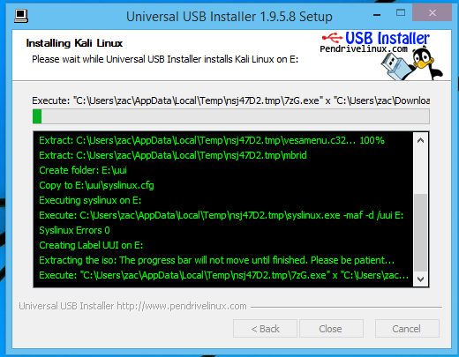UUI running as per the directions on the kali documentation for USB installation

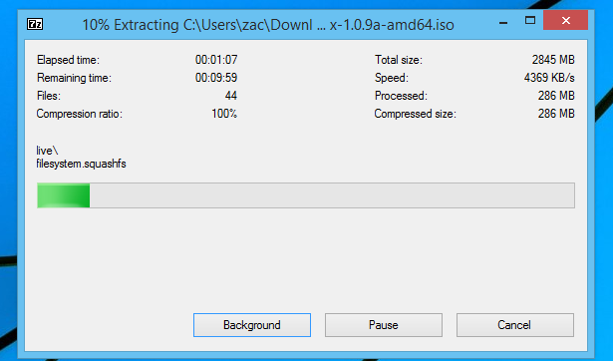The usb installer working to extract the files using 7zip.

End results of all attempts, it gives me a USB, but I cannot do anything with it. It does not have any executables under any of the files listed.

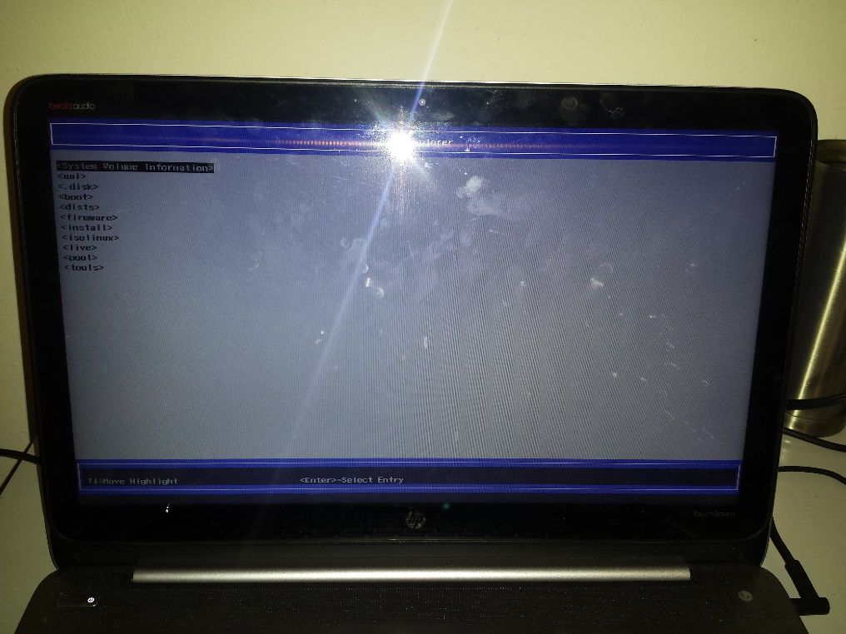

I tried 3 different USB keys

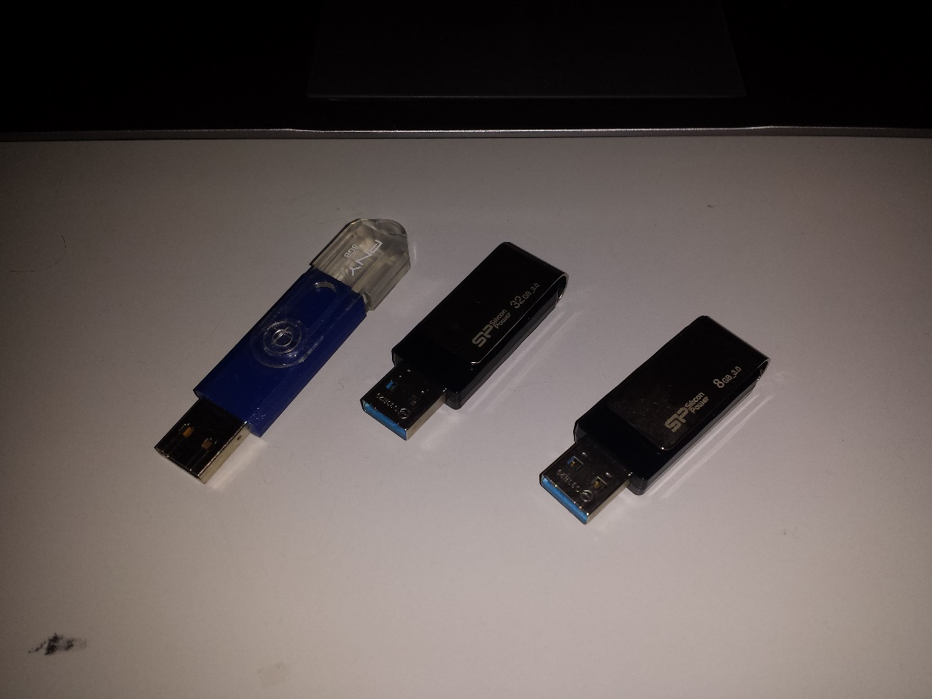

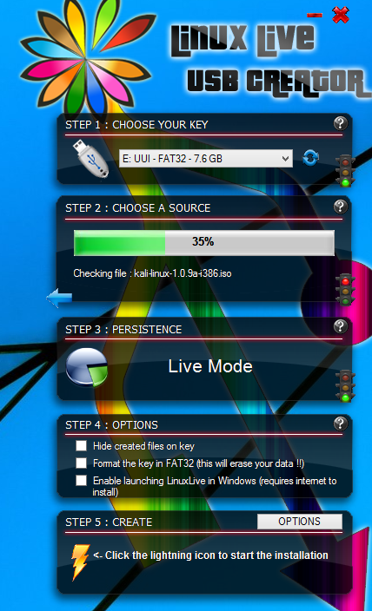Attempted with Linux Live USB creator, no success. I also used different versions as well to rule out a hardware issue

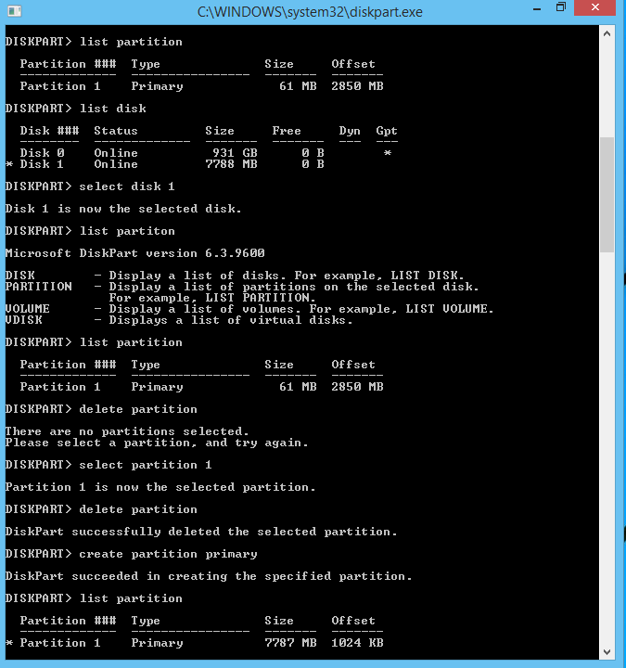Had to fix one of my USB drives at one point

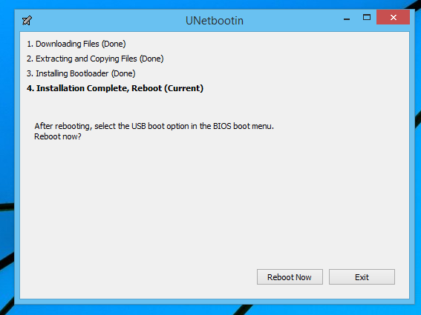Tried again with Unetbootin, same results

Attempted with win32disk imager

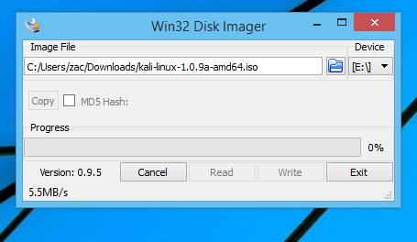

Another screen of 7zip at work

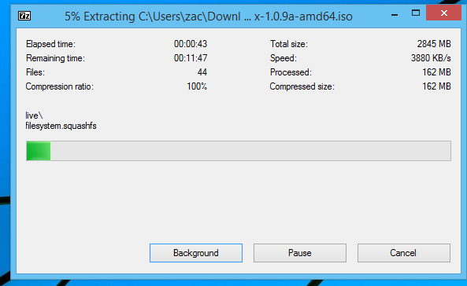

Attempted with Yumi, as per your advice

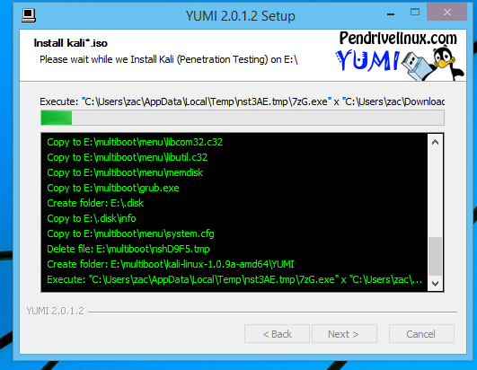

Conclusion:

Yumi ended up failing to give me a bootable USB drive as well. I decided to check out some of the forums on kali and as it turns out, there are a few other people with the same or similar problem. However, none of the forums had a solution to this problem. The forums are saying it is a distribution error on their part and hopefully it will get fixed soon. This was sad news for me, because I was really looking forward to running Kali linux and being able to complete my final project. All was not a waste though, I learned that some distributions of linux can be tempermental, and I learned how to partition a USB drive in windows (in a new and dangerous way). I am confident I could complete the project if I had gotten Kali to work.

Kali linux can be found at kali.org

Metasploit can be found at metasploit.com

I planned on using an old Galaxy S4 I had laying around the house.

The project did ultimately fail, due to an uncooperative kali linux distro.